I2C Objective Questions Set 4
- Which among the below is the speed of I2C Bus for High Speed Mode (HS).
a) 100 kbits/s b) 400 kbits/s
c) 1 Mbits/s d) 3.4 Mbits/s
- PseudoCode is an imaginary programming language that any programmer should be capable of porting to his/her favorite language.
a) True b) False
- For the figure given below,which I2C Bus Event conforms
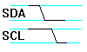
a) I2C Start b) I2C Stop
c) I2C Transmitting a Byte to Slave Device d) I2C Receiving a Byte from a Slave Device
- For the figure given below,which I2C Bus Event conforms
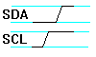
a) I2C Start b) I2C Stop
c) I2C Transmitting a Byte to Slave Device d) I2C Receiving a Byte from a Slave Devic
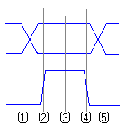
- For the figure given ,which I2C Bus Event conforms
a) I2C Transmitting a Byte to Slave Device
b) I2C Receiving a Byte from a Slave Device
c) Both a & b
d) None of the above
- For I2C No Acknowledge Bus Event/Condition which of below are true ?
a) The slave is not there (in case of an address) .
b) The slave missed a pulse and got out of sync with the SCL line of the master.
c) The bus is "stuck". One of the lines could be held low permanently.
d) All of the above
- Match the below ?
a) After a master has read a byte from a slave 1) 1
b) After a master has written a byte to a slave 2 ) 0
c) Last bit after 7bit I2C slave address for write 3) No Acknowledge
d) Last bit after 7bit I2C slave address for read 4) Not Acknowledge(NACK)
- Are there any stand-aloneI2C controller?
a) Yes b) No

- Which among the below in not an I2C Slave but an parallel-bus to I2C bus protocol converter .
a) AT24C01 b) DS1307 c) DS1621 d) PCF8584
- The I2C slave DS1621 is a/an
a) RTC b) EEPROM c) ADC/DAC d) None of the mentioned
- The pin diagram given below represents an I2C slave used/available in your 8051 training kit. What type of slave does it represent ?
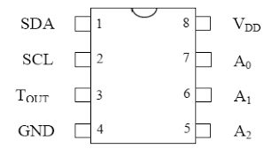
a) RTC b) EEPROM c) ADC/DAC d) None of the mentioned
- Given below for DS1621 Temperature/Data Relationships
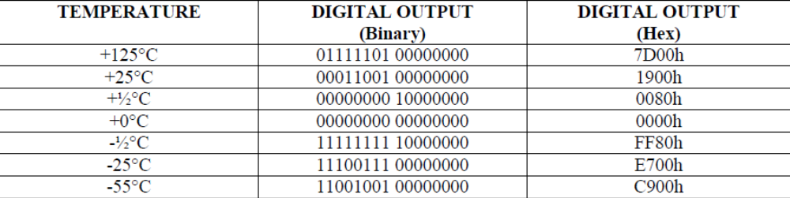
What would be the temperature in degree Centigrade if the Digital Output (Hex) is read as 4180h ?
a) 41 degrees Centigrade b) 41.5 degrees Centigrade
c) 65 degrees Centigrade d) 65.5 degrees Centigrade

- The Wave form for serial communication given below for DS1621 represents
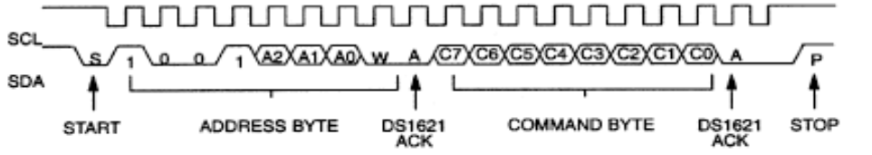
a) send a command byte (Start/Stop Convert)
b) write to a two-byte register (TH,TL)
c) read from a two-byte register(TH,TL temperature)
d) None of the above
- The Wave form for serial communication given below for DS1621 represents
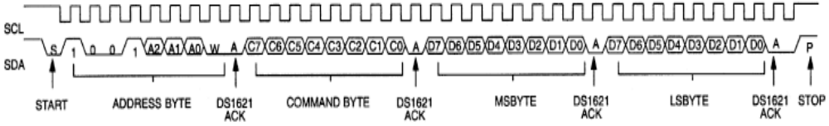
a) send a command byte (Start/Stop Convert)
b) write to a two-byte register (TH,TL)
c) read from a two-byte register(TH,TL temperature)
d) None of the above
- The Wave form for serial communication given below for DS1621 represents
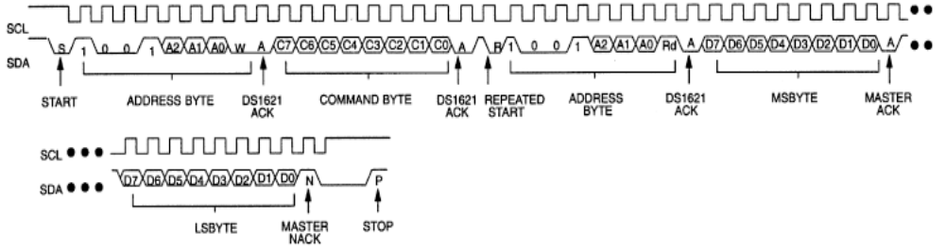
a) send a command byte (Start/Stop Convert)
b) write to a two-byte register (TH,TL)
c) read from a two-byte register(TH,TL temperature)
d) None of the above
- The ________ command is used for Read Temperature in DS1621.
a) AAH b) 22H c) EEH d) ACH
- The temperature is represented in DS1621 using _______ valid bits.
a) 8 b) 9 c) 12 d) 16
- For the wave form in question 25 how many occurrences of i2c bus events ?
a) 6 b) 10 c) 12 d) 13
- Which pin diagram given below could be that of an I2C slave RTC DS1307 available in your hadware 8051 training kit ?
a) b) c) d) Not given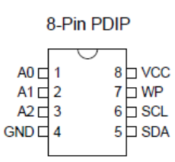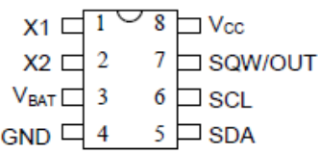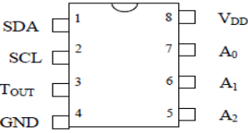

- The i2c waveform given below represents ?
a) start & stop b) data validity c) output acknowledge d) None
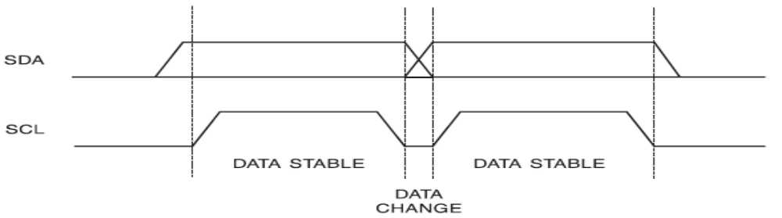
- The i2c waveform given below represents ?
a) start & stop b) data validity c) output acknowledge d) None
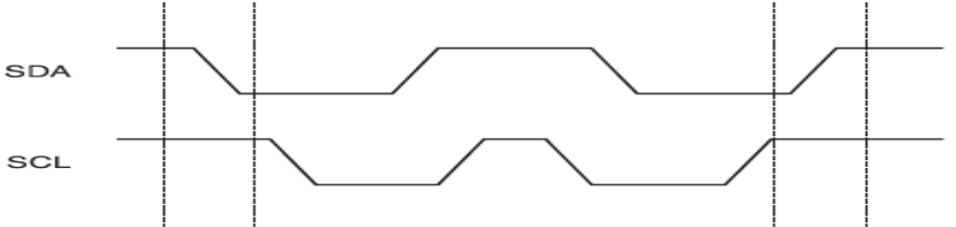
- The i2c waveform given below represents ?
a) start & stop b) data validity c) output acknowledge d) None
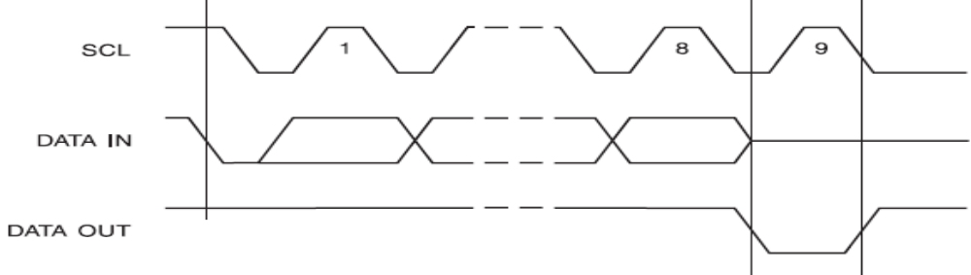
- Which among the illustrative algorithms given below for i2c slave EEPROM AT24C01 in options matches mostly/completely to the routine definition given below after the options ?

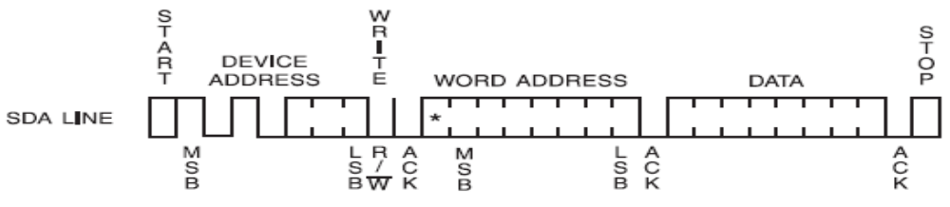

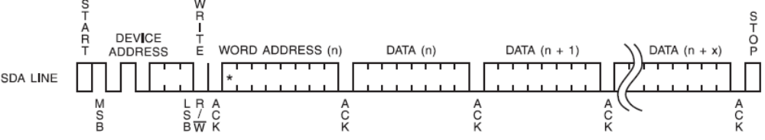

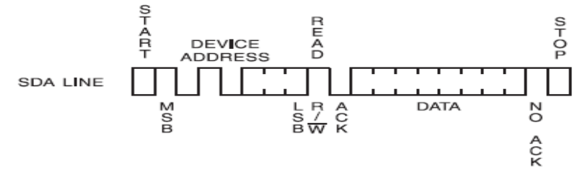

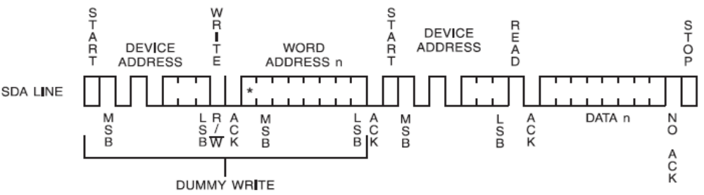
u8 i2cDevRead(u8 slaveAddr,u8 buffAddr)
{
u8 buff;
i2cStart();
i2cWrite(slaveAddr);
i2cAck();
i2cWrite(buffAddr);
i2cAck();
i2cReStart();
i2cWrite(slaveAddr|1);
i2cAck();
buff=i2cRead();
i2cNoAck();
i2cStop();
return buff;
}

- From the table given below, the Write Protect (WP) pin for AT24CXX should be __________
for write/read operations.
- Grounded b. At GND c. a or b d. At VCC
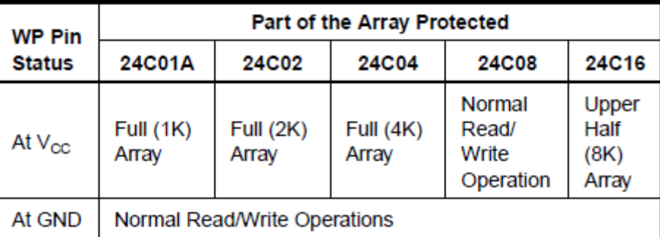
- Which among the routines definitions given below matches with any one of the options of illustrative algorithms given below for question 34 for i2c slave EEPROM AT24C01 ?
a) b)
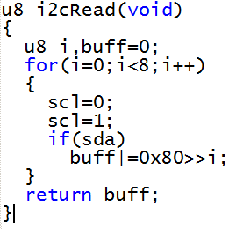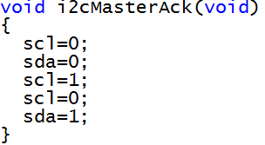
c) d)
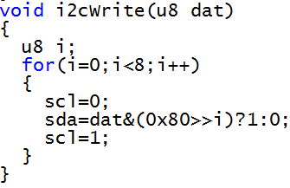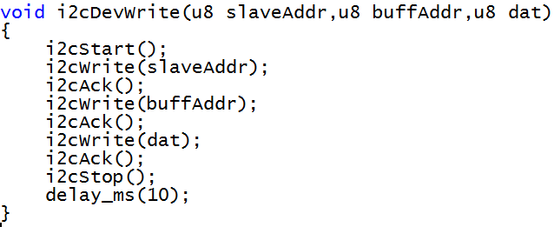
- For the "main's" block code given below for i2c slave EEPROM AT24C01 ,
main()
{ u8 t;
led=1; //led on active high
i2cDevWrite(0xa0,0x00,'A');
t=i2cDevRead(0xa0,0x10);
delay_ms(1000);
if(t = ='A') { led=~led; }
while(1);}
Which option best describes the code and hardware functionality ?
- The LED turns OFF after ~ 1s c. The LED turns ON after ~ 1s
- The LED may remains ON/OFF even after ~1s d. The LED may turn OFF after ~1s
- In single master i2c bus systems, clock synchronization and arbitration are not needed. (True/False)
- Two masters can begin transmitting on a free bus at the same time. (True /False)

- ______________________ is the method for deciding, which one, among two masters transmitting on a free bus at the same time, takes control of the bus and complete its transmission.
- clock synchronisation b) arbitration c) both a & b d) none of the mentioned

- Clock synchronization is performed using the wired-AND connection of I2C interfaces to the SCL line. (True/False)

Based on the figure given below regarding i2c Protocol clock synchronisation during arbitration procedure, answer 41 to 45

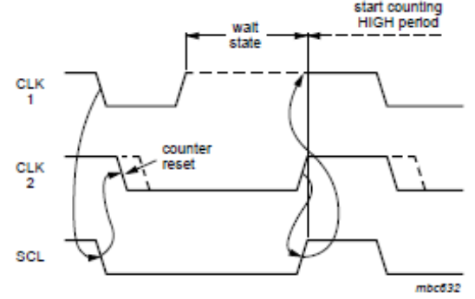

- There are _________ masters available on the bus.

- A synchronized clock is generated with its _______ period determined by the master with the longest clock ______ period.

- A synchronized clock is generated with its _______ period determined by the one with the shortest clock ______ period.

- A ______________ transition on the SCL line causes the masters concerned to start counting off their LOW clock period.

- Slaves are not involved in the arbitration procedure. (True/False)

- Twomasters can actually complete an entire transaction without error, as long as the transmissions are identical. (True/False)

- Arbitration proceeds _____ by ____. During every bit, while SCL is _____ each master checks to see if the SDA level matches what it has _____. (Best Fit Answer)
- HIGH b) sent c) received d) bit

- Information is lost during the arbitration process. (True/False)

- Between competing Masters there is no central master, nor any order of priority on the bus.(True/False)

- Between competing 2 Masters during arbitration the undefined conditions is/are__________ .
- Master 1 sends a repeated START condition and master 2 sends a data bit.
- Master 1 sends a STOP condition and master 2 sends a data bit.
- Master 1 sends a repeated START condition and master 2 sends a STOP condition.
- All the above

- The acknowledge takes place after every byte.When SDA remains HIGH during this ninth clock pulse, this is defined as the Not Acknowledge (NACK) signal.The master can then generate
- a STOP condition to abort the transfer .
- a repeated START condition to start a new transfer.
- either a or b
- both a and b

- As per I2C Bus Specification Rev 6,April 2014,There are ______ conditions that lead to the generation of a NACK.

- The Conditions that lead to generation of NACK signal are
- No receiver is present on the bus with the transmitted address so there is no device to respond with an acknowledge.
- The receiver is unable to receive or transmit because it is performing some real-time
function and is not ready to start communication with the master.
- During the transfer, the receiver gets data or commands that it does not understand.
- During the transfer, the receiver cannot receive any more data bytes.
- A master-receiver must signal the end of the transfer to the slave transmitter.

- The figure given below represents
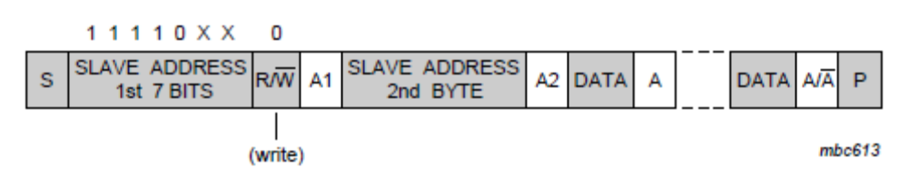
- A master-transmitter addressing a slave receiver with a 7-bit address
- A master-receiver addresses a slave-transmitter with a 10-bit address
- A master-transmitter addresses a slave-receiver with a 10-bit address
- A master-receiver addresses a slave-transmitter with a 10-bit address

- The figure given below represents
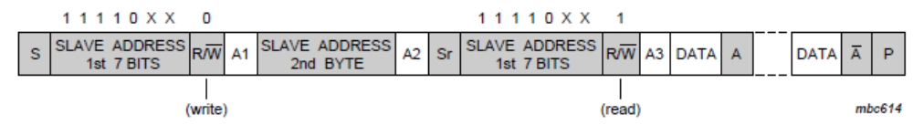
- A master-transmitter addressing a slave receiver with a 7-bit address
- A master-receiver addresses a slave-transmitter with a 10-bit address
- A master-transmitter addresses a slave-receiver with a 10-bit address
- A master-receiver addresses a slave-transmitter with a 10-bit address

- Devices with 7-bit and10-bit addresses can be connected to the same I2C-bus. (True/False)

- Both 7-bit and 10-bit addressing can be used in all bus speed modes. (True/False)

- ___________pauses a transaction by holding the SCL line LOW. The transaction cannot continue until the line is released HIGH again.
- Clock stretching
- Arbitration
- clock synchronisation
- None of the mentioned

- The general call address is for addressing every device connected to the I2C-bus at the same time.(True/False)
- __________ 7 bit address with R/W bit=0 represents general call address.

Using the figure below with respect to 7 bit slave address in I2C protocol,answer questions 61 & 62
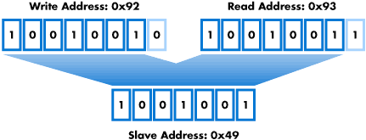

- If the Write address =0xAE and Read Address=0xAF,then Slave Address=_________.

- If Slave address 0xD0,then Write address =0x___ and Read Address=0x___.

Using the information given below with respect to 7 bit slave addresses in I2C protocol,answer questions 63 & 64

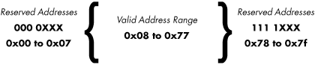
- The Slave Address of question 61 is falling in __________ address range _____ to _____.

- The Slave Address of question 62 is falling in __________ address range _____ to _____.

Given the figure below for TTL logic levels,Answer questions 65 - 68
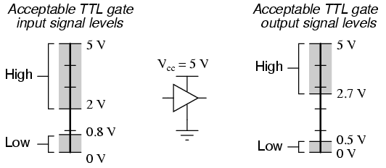

- V_{OL} = 0.2v implies digital status = _________ .
- V_{IL} = 0.5v implies digital status = _________ .
- V_{IH} = 2.5v implies digital status = _________ .
- V_{OH} = 2.7v implies digital status = _________.

Given the figure below for TTL logic levels,Answer questions 69 - 70
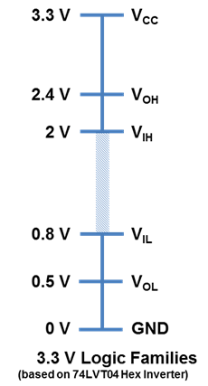

- Output = High implies V_{OH} = _________ .
- Output = LOW implies V_{OL} = _________ .
- Input = LOW implies V_{IL} = _________ .
- Input = High implies V_{IH} = _________ .

